T: 800.503.4417 ext. 1 | E: sales@p3adaptive.com | W: www.p3adaptive.com
Power BI Data Modeling Best Practices
Prepared For:
United Performance Metals (UPM)
Prepared By:
Kristyna Ferris
Solutions Architect
kferris@p3adaptive.com
Date Created: | October 10, 2024
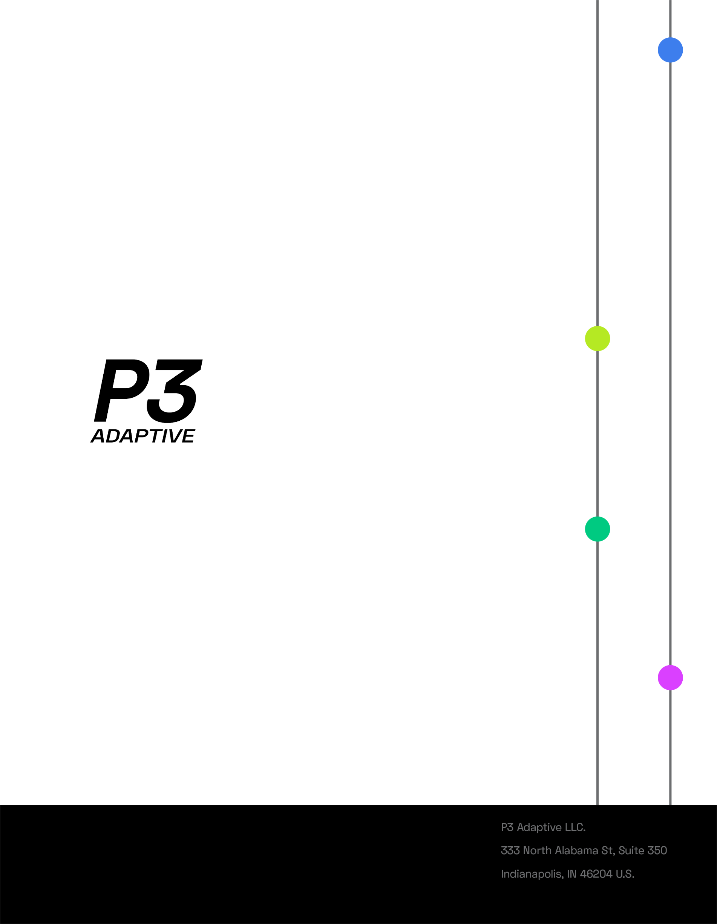

Executive Summary
P3 Adaptive completed a thorough Power BI strategic assessment including a Tenant Setting Analysis, report sharing best practices, data modeling best practice, and licensing options. In addition to the contents of this documentation, P3 also provided a Power BI Management report and list of datasets to consolidate.
This document covers our best practices around report development and semantic models. In general, simplest is best. That means fewer semantic models, fewer measures, fewer pages in the report, simple visuals, and fewer business questions answered per report. The simpler a report is, the easier it is to understand, to edit, and to refresh.

Detailed Analysis

UPM Semantic Model Next Step Recommendations

Reduce Duplicate Semantic Models
Looking at just the names of semantic models, we can identify 8 semantic models that have duplicates across multiple workspaces. 3 of those semantic models have a record in the QA workspace, so let’s exclude those from our analysis. Looking at the remaining duplicate datasets, we recommend starting on the duplicates that have high activity since they are likely hitting your interactive capacity harder. In order of activity, the reports to focus on would be Backlog, UPM GMROI, NCRReport, Production Backlog, Customer Information – Marketing.
Reducing duplicate semantic models can help lessen the refresh load by only grabbing data one time for multiple reports. Additionally, multiple datasets means multiple datasets to maintain which increases the risk of measures and data being different. Having a single source of truth is vital to ensuring users are looking at the same set of data and can communicate about business processes effectively and efficiently.
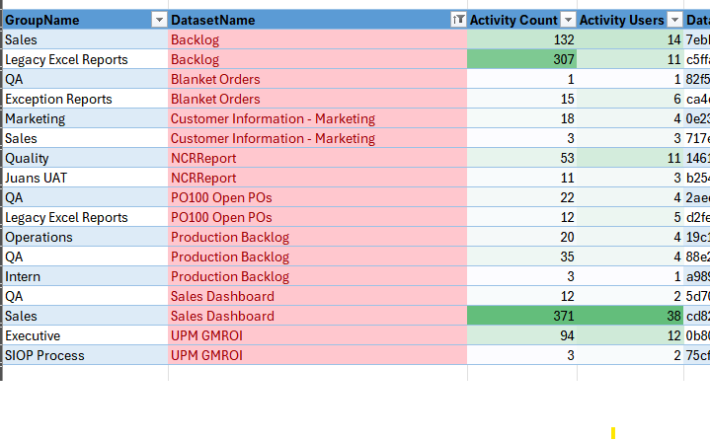

Star Schema

Using a star schema in Power BI has several advantages:
- Simplified Data Model: The star schema organizes data into facts and dimensions, making it easier to understand and navigate. This simplicity helps users grasp relationships quickly.
- Improved Performance: Star schemas optimize query performance. Since facts and dimensions are separated, queries can run faster, especially when dealing with large datasets.
- Efficient Data Processing: Power BI can process and aggregate data more efficiently with a star schema, as it minimizes the number of joins needed.
- Enhanced Reporting and Analytics: With clear relationships between dimensions and facts, creating reports and visualizations becomes more intuitive and straightforward.
- Flexibility for Analysis: The design supports various analytical scenarios, allowing users to slice and dice data easily without altering the underlying model.
- Easier Maintenance: A well-structured star schema is easier to maintain and update, which is crucial as business needs evolve.
- Support for DAX Calculations: Star schemas are designed to work well with DAX (Data Analysis Expressions), enhancing your ability to create complex calculations and measures.
Overall, adopting a star schema in Power BI can lead to better performance, easier maintenance, and a more user-friendly experience for report creators and consumers alike.
Reference: Understand star schema and the importance for Power BI - Power BI | Microsoft Learn
SQLBI did an amazing overview of comparing the impact of a single wide table versus a star schema. Highly recommend reviewing this to understand how star schema aids in compression, refresh speed, visual loading speed, and scalability of a semantic model - Power BI – Star schema or single table - SQLBI.

Deep dive on the Backlog Semantic Models

The Backlog semantic model has two copies – one in Sales workspace and the other in the Legacy Excel Report workspace. Looking at the backend of these models, it appears that the tables match other than one additional table in the Sales version of the Backlog semantic model. I reviewed the reports, and that extra table is not used in any of the visuals, measures, or filters meaning there’s no need for it. The Backlog model is fairly small and refreshes easily at the moment, but fixing the red flags listed below can make it scalable in the future. Also, feel free to apply the concepts listed below to some larger data models like the RTB dashboard and Sales Dashboard.
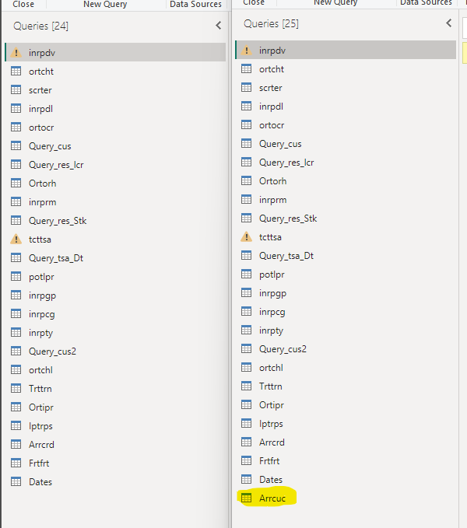
The visuals are also nearly identical (only difference is the default filters and a backlog division page in the Sales version). To consolidate these semantic models, you could have one for two separate reports and publish the reports in two separate workspaces.
The other thing to consider about these reports is that they are essentially data dumps. These are highly used, so there’s a high potential that business users are exporting these data dumps and making various reports and visuals from them. It may be beneficial to reach out to these users and see if IT can assist them in productionalizing views of this data.
Digging a bit deeper, I looked at the model layout to evaluate if it’s using a proper star schema. A few red flags popped up immediately. For context, the main fact table is Ortorh.
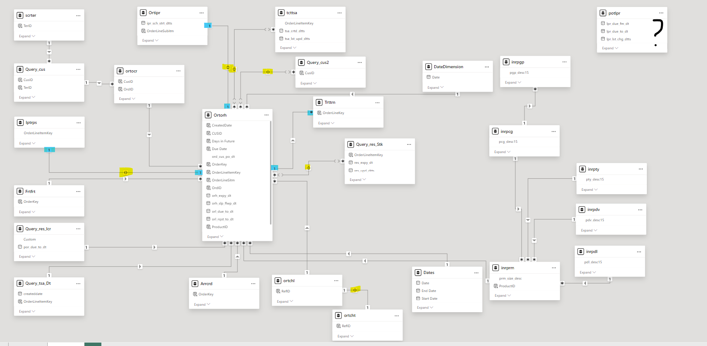
Zoomed in:
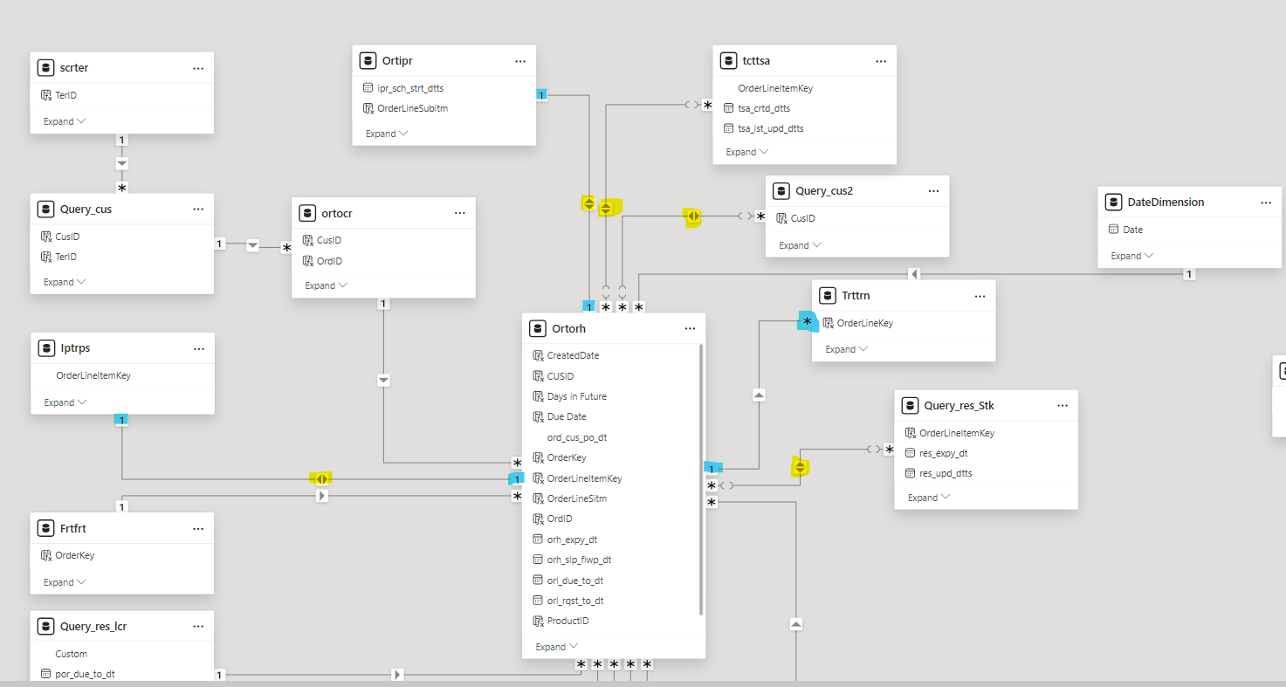
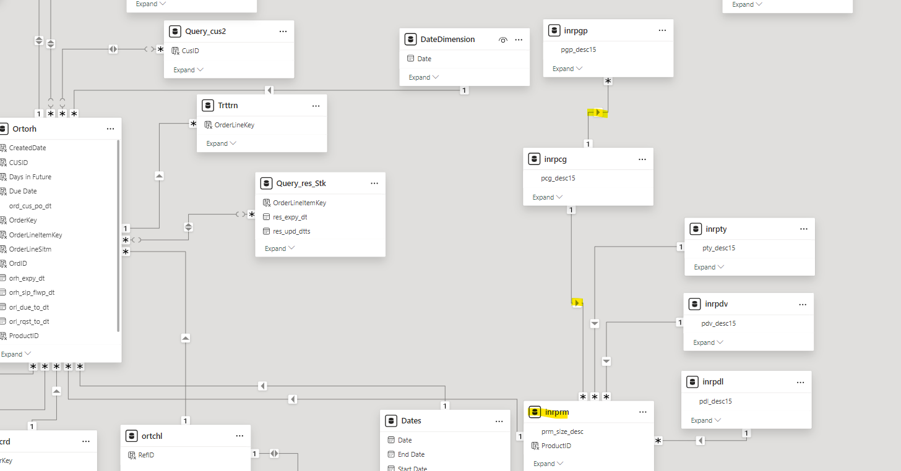
Model Red Flags:
- Bi-directional filters
  - Bi-directional filters are between the following tables:
    - Ortipr 1 :1 Ortorh
    - Tcttsa *:* Ortorh
    - Query_cus2 *:* Ortorh
    - Ortcht 1:1 Ortchl
    - Lptrps 1: 1 Ortorh
  - Bi-directional cross-filters in a data model might create ambiguous paths in the chain of relationships, resulting in very dangerous models as numbers become unpredictable.
  - Reference links
    - Bidirectional relationships and ambiguity in DAX - SQLBI
    - Bi-directional relationship guidance - Power BI | Microsoft Learn
    - When you should avoid using bidirectional filters in Power BI (sqlbits.com)
- 1:1 relationships to the main fact table
  - 1:1 relationships mean that the two tables have the same level of granularity. When there are 1:1 relationships tied to the main fact table, that tells me that we are storing a lot of extra data because the main fact table records are likely duplicated in those 1:1 tables. This creates a lot of model bloat and can lead to poor performance in the future.
- One table that aren’t related to anything else
  - Why is potlpr included in the model? It isn’t related to any other table so it cannot be used as a filter and no other tables can filter it.
- Many calculated columns that could be pushed upstream
  - DAX is often slower than M (the language of Power Query) or SQL. For simple column creations like concatenating other columns together, we can push that logic upstream of the report to enable faster refreshes.
  - Reference links
    - Power BI: Custom Column Vs Calculated Column | Power BI (devoworx.net)
- Unused tables in the report:
  - DateDimension
  - Dates
  - Inrpcg
  - Inrpdl
  - Inrpdv
  - Inrpgp
  - Inrpty
  - Ortchl
  - Ortcht
  - Ortocr
  - Potlpr
  - Query_cus2
  - Query_res_stk
  - Tcttsa
  - Trttrn
    - These can likely be removed from the report which will make the refreshes even faster.
- It would also be ideal to change the table names so it’s clearer what’s included in them.

